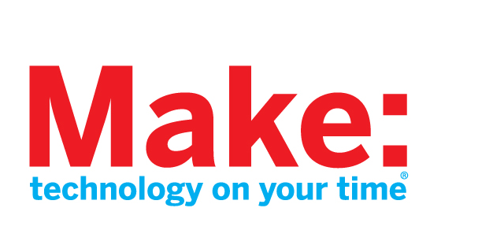

About Make Magazine
Make magazine is the first magazine devoted entirely to Do-It- Yourself (DIY) technology projects. Make magazine unites, inspires, informs, and entertains a growing community of resourceful people who undertake amazing projects in their backyards, basements, and garages.

Makezine.com, the award-winning website, is the companion site to Make magazine. Hosted by Phil Torrone, Makezine.com gets more than three million unique visitors per month. Makezine.com is the leader of DIY websites, bringing new content to the Make community daily with its devoutly followed blog and weekly video podcasts.

Make magazine is published by Maker Media, a division of O'Reilly Media, Inc. Maker Media also publishes CRAFT Magazine (craftzine.com), the first project-based magazine dedicated to the modern craft renaissance and the imaginative people who are transforming traditional crafts; publishes popular DIY book series including Hacks, DIY Science, Make: Projects, and Craft: Projects; and distributes top-quality DIY kits and books from around the planet at the Maker Shed (makershed.com).

Maker Media also produces the annual Maker Faire (makerfaire.com), a two-day, family-friendly event that celebrates the DIY mindset. It's for creative, resourceful people of all ages and backgrounds who like to tinker and love to make things.

